### Scenario 1

Tom, a grade 12 student in Brisbane, has good results in all of the subjects in his school. He is finding a major in the University which can guarantee a job in his state (Queensland) with a good income (>=80K) in the future. Based on the current job market dataset, which major and the related subjects do you recommend him? Explain your choice.

**Explanation:**

As we are aware that Tom has just passed out of school with good results in all of his subjects and he is looking for a major in the University which can guarantee a job in his state (Queensland) with a good income (>=80K) in the future, I have come up with many insights after thorough analysis of the job market dataset provided. All of the insights are discussed below:

1. We started our analysis by finding all the locations in the state of Queensland, Tom's home state, and we found the following locations:

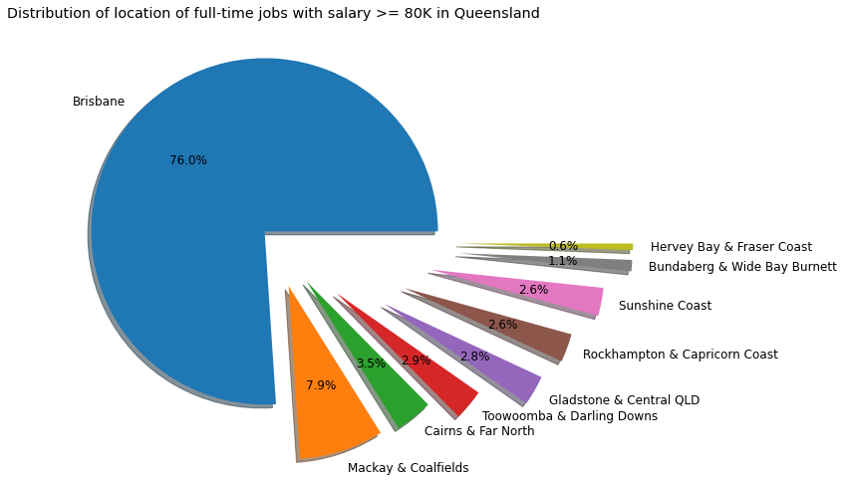

1. We then proceeded by finding all the job-types in the state of Queensland that pay at least 80K salary. We found the following types:

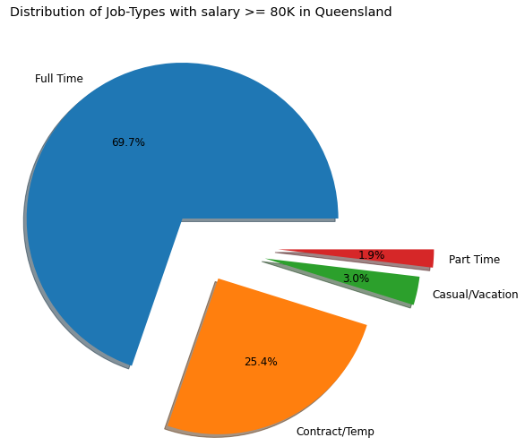

* + Full Time
  + Contract/Temp
  + Casual/Vacation
  + Part Time

1. For job-security purpose, Tom should consider Full Time job-type because that will be more stable as compared to other job-types
   * There are total 5036 Full Time jobs with salary >= 80K in Queensland

4. Next, we found the distribution of all the lowest salary Full-Time jobs with minimum salary 80K in Queensland and came up with the following insights:

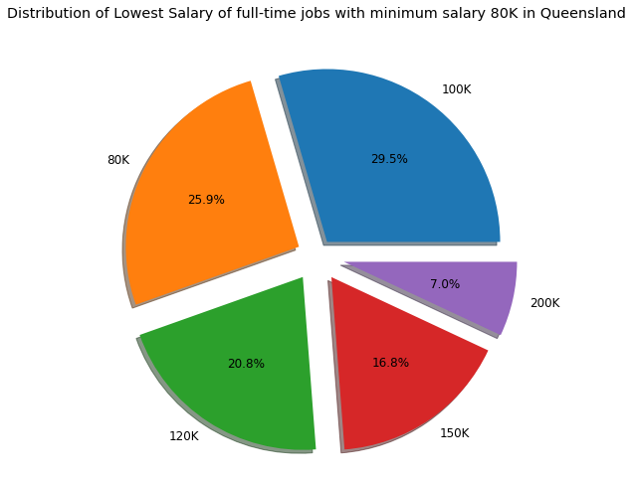

* + Jobs with lowest salary 100K make upto 29.5% of all jobs with salary >= 80K in Queensland
  + Jobs with lowest salary 80K make upto 25.9% of all jobs with salary >= 80K in Queensland
  + Jobs with lowest salary 200K make upto 7% of all jobs with salary >= 80K in Queensland
  + The highest salary is: 250K
  + Average lowest salary is: 114.34K

5. Next, we found the distribution of all the highest salary Full-Time jobs with minimum salary 80K in Queensland and came up with the following insights:

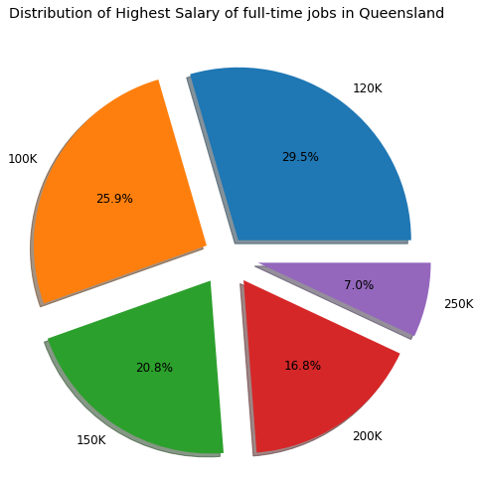

* Jobs with highest salary 120K make upto 29.5% of all the highest paying jobs with in Queensland
* Jobs with highest salary 100K make upto 25.9% of all the highest paying jobs in Queensland
* Jobs with highest salary 200K make upto 7% of all the highest paying jobs in Queensland
* The highest salary is: 250K
* Average highest salary is: 143.60K

From the above two pie plots(in point 4 and 5), we calculated the **average salary** of the Full Time jobs with salary >= 80K in Queensland, which is **128.98K**

1. Next we did an analysis of Job-Sector Distribution and came up with the following insights:

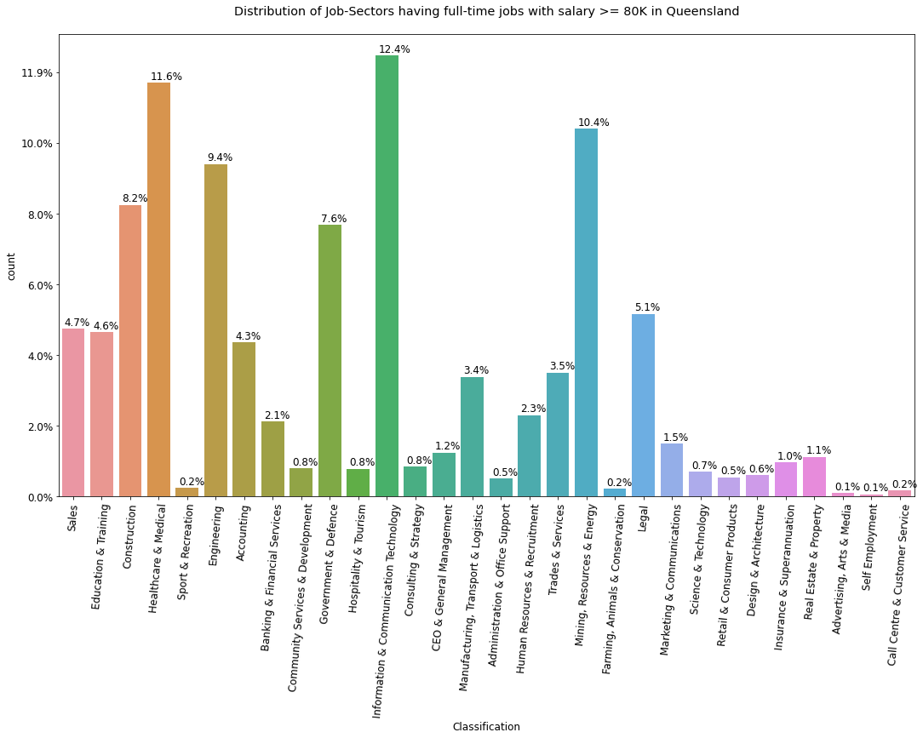

* Tom should consider having a major and related subjects to the following job-sectors(Classifications ) that contribute more than 60% jobs with salary >= 80K in Queensland:
  + Information & Communication Technology
  + Healthcare & Medical
  + Mining, Resources & Energy
  + Engineering
  + Construction
  + Government & Defence

6.1. Some of the SubClassifications in the Top 6 Classifications(plot in 6th point) are given below:

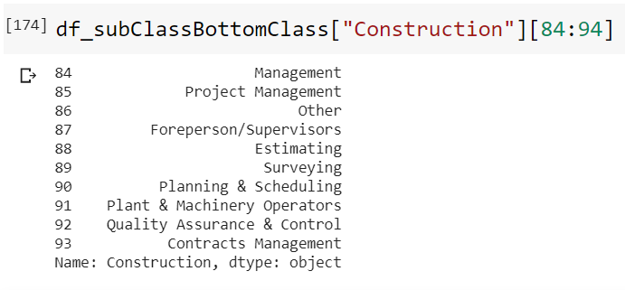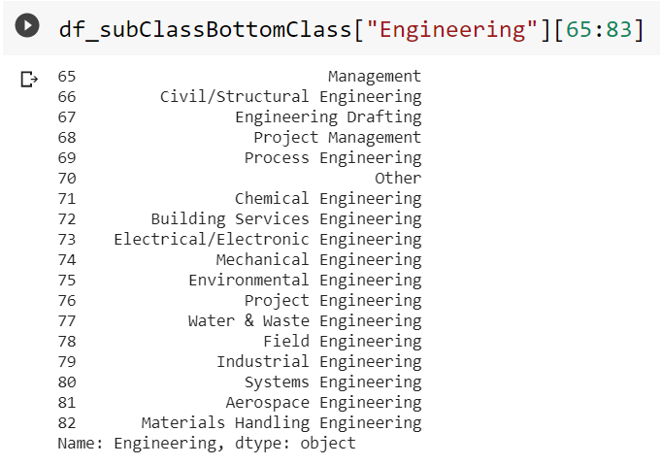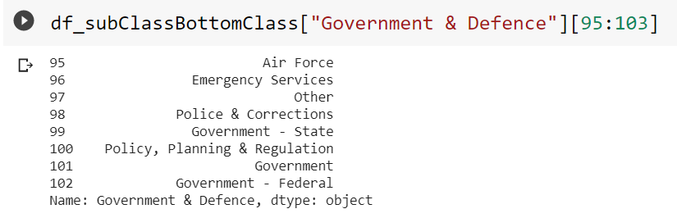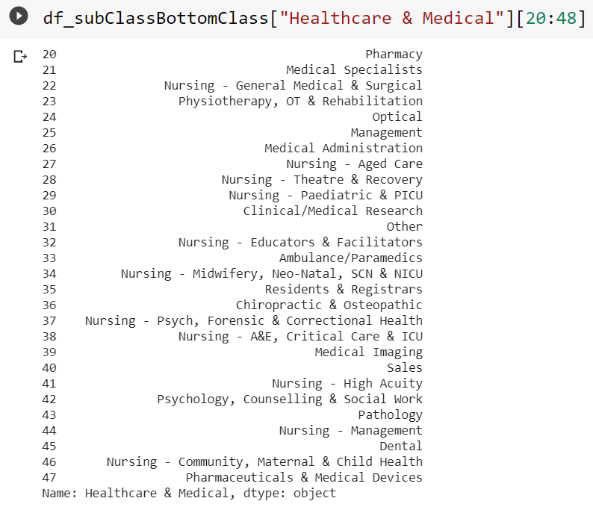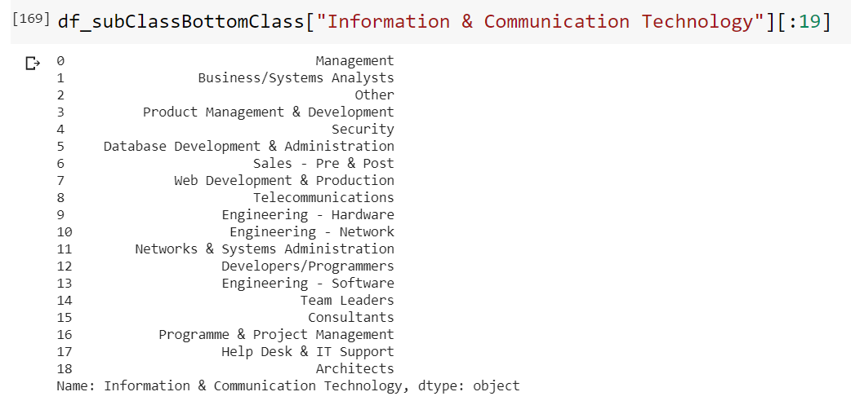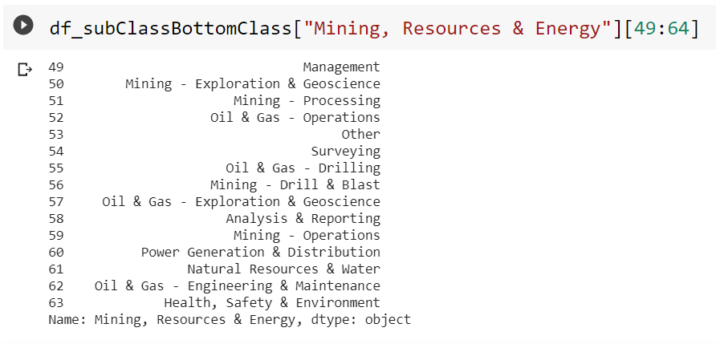

6.2. Salary of some of the SubClassifications in the Top 6 Classifications(plot in 6th point) are given below:

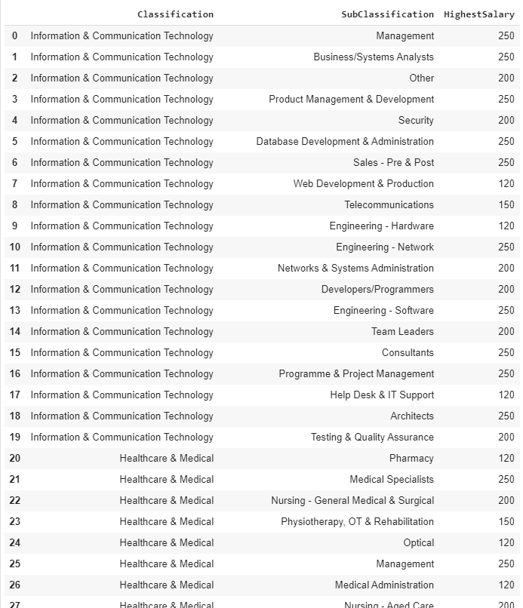

(list has 104 rows, displaying only a few here, to view more check out the Jupyter notebook)

6.4. Some of the SubClassifications in the Bottom 5 Classifications(plot in 6th point) are given below:

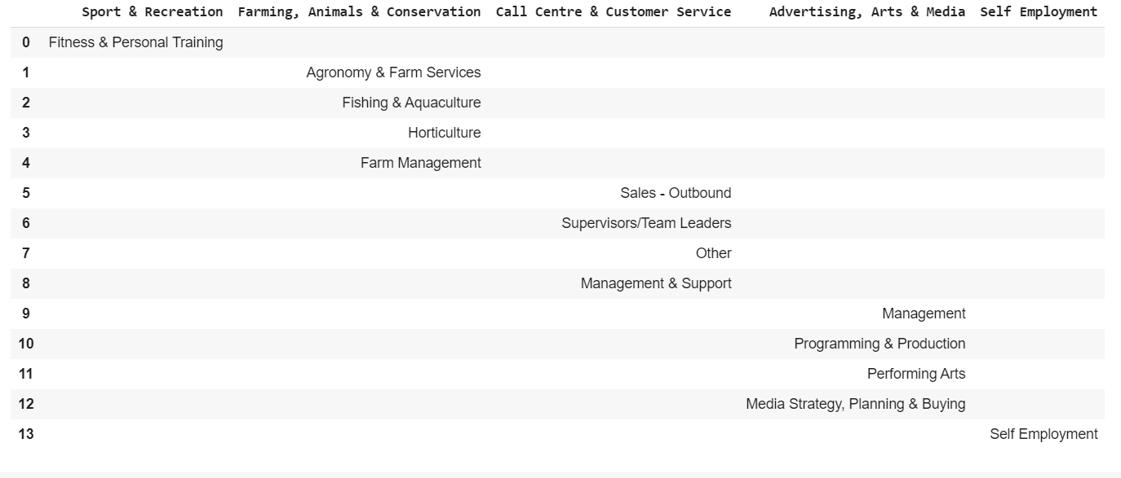

6.5. Salary of some of the SubClassifications in the Bottom 5 Classifications(plot in 6th point) are given below:

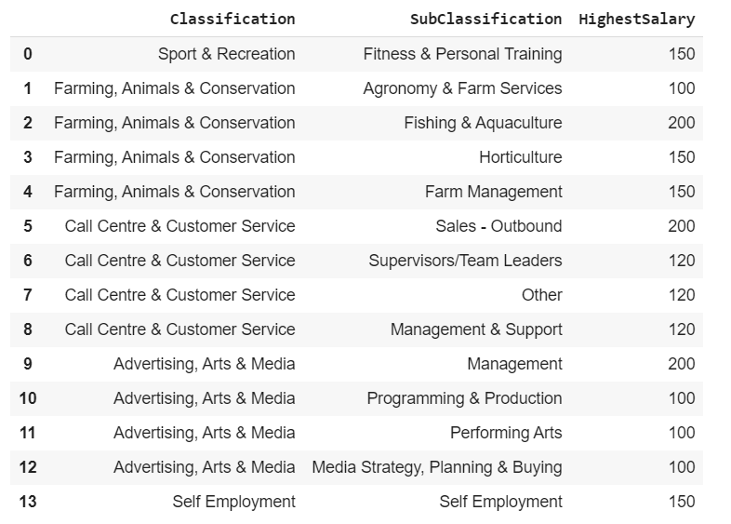

1. Next, we did analysis of Job-Role Distribution which helped us getting better understanding of the current job-market and which led us to come to conclusion which majors and their corresponding subjects should be useful to Tom. We came up with the following insights:

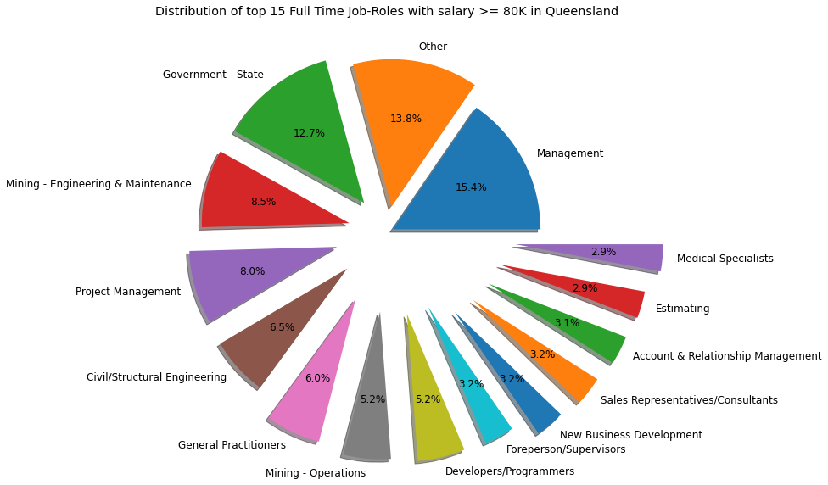

1. After all the analysis we found out the following industries(Classifications):
   * Information & Communication Technology
   * Healthcare & Medical
   * Mining, Resources & Energy
   * Engineering
   * Construction
   * Government & Defence

would be a good options for Tom to choose from for making a career decision and these industries have the following job roles(Sub Classifications):

* Management

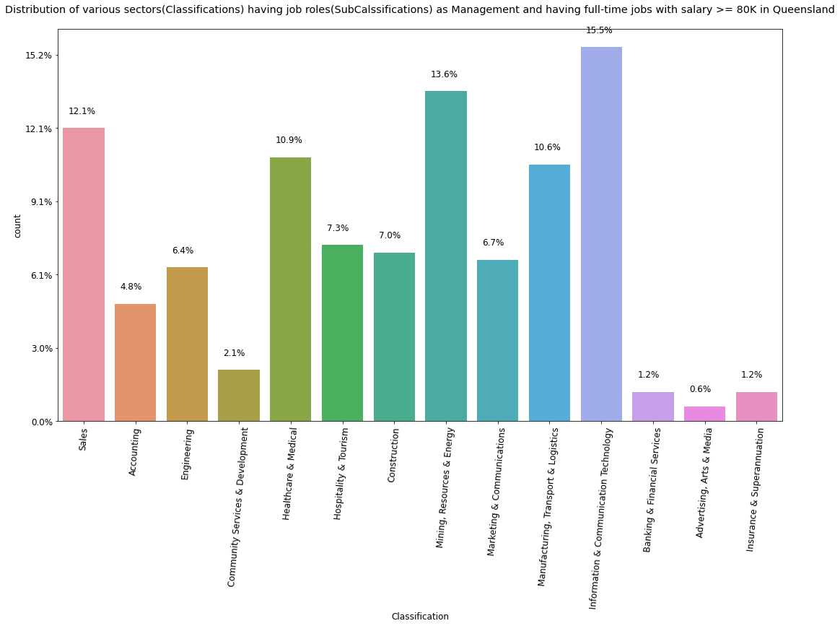

* Others
  + From industries such as:
    - Education & Training
    - Mining, Resources & Energy
    - Information & Communication Technology
    - Healthcare & Medical
    - Engineering
    - Construction

Since, job-roles(subClassifications) as “Others” constitute 2nd largest number(13.8%) of full time jobs with salary >= 80K in Queensland, we therefore analysed it further. We found the following insights:

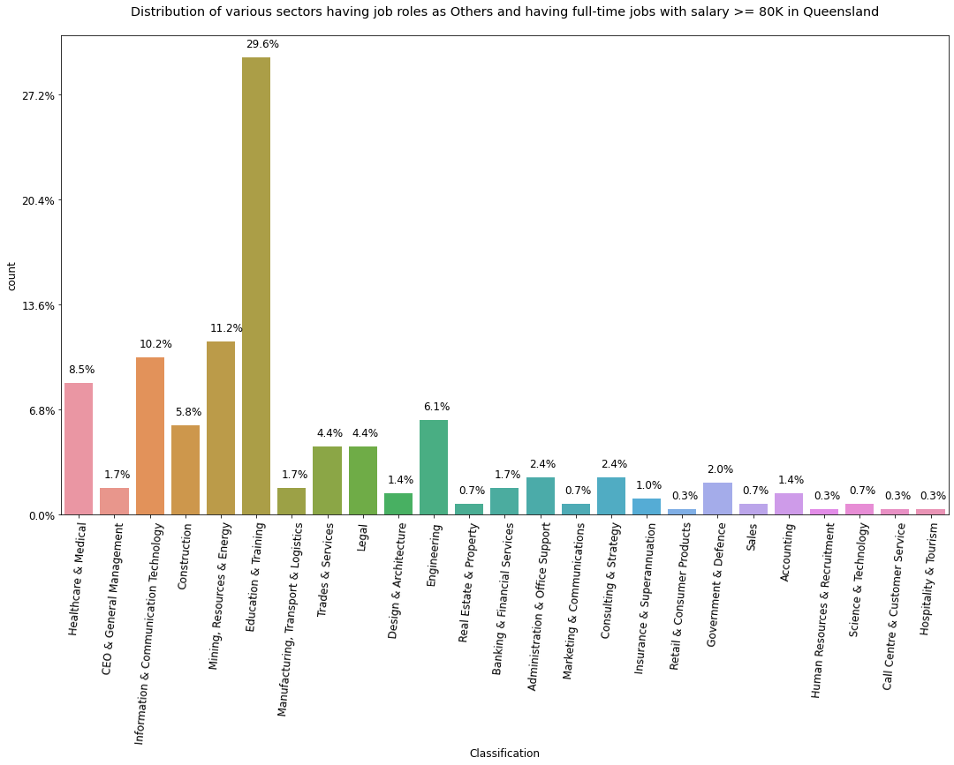

* Government - State

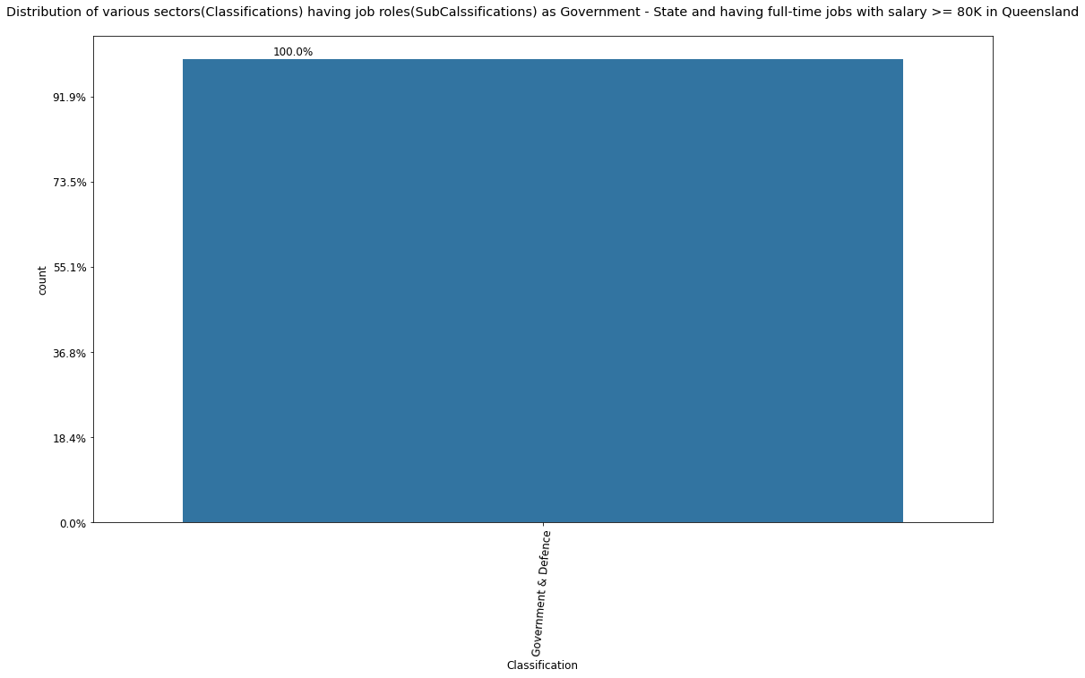

* Mining - Engineering & Maintenance

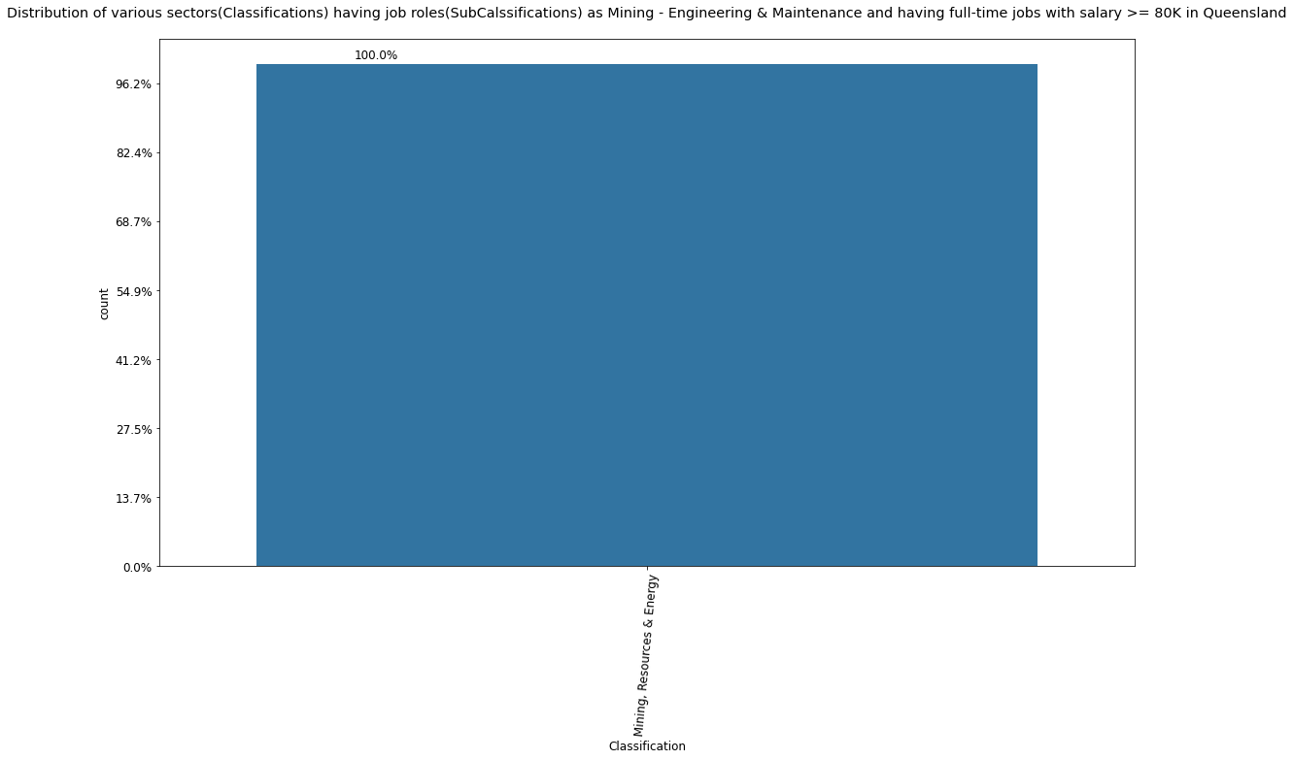

* Project Management

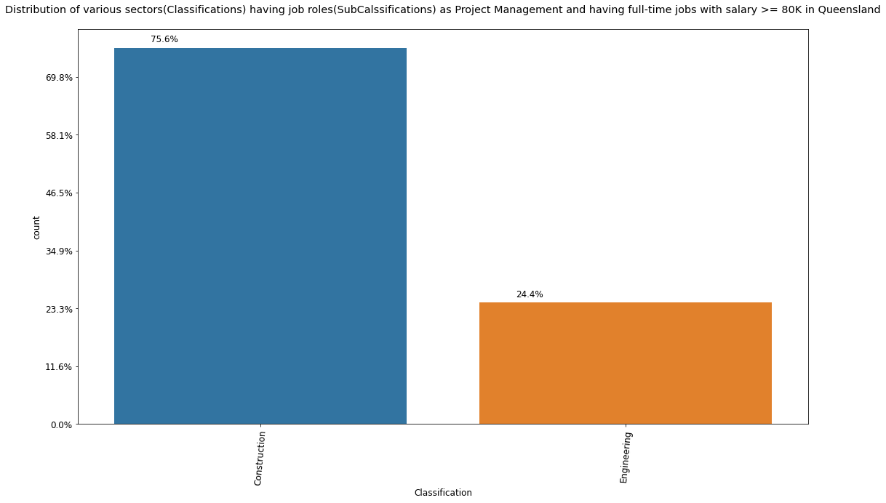

* Civil/Structural Engineering

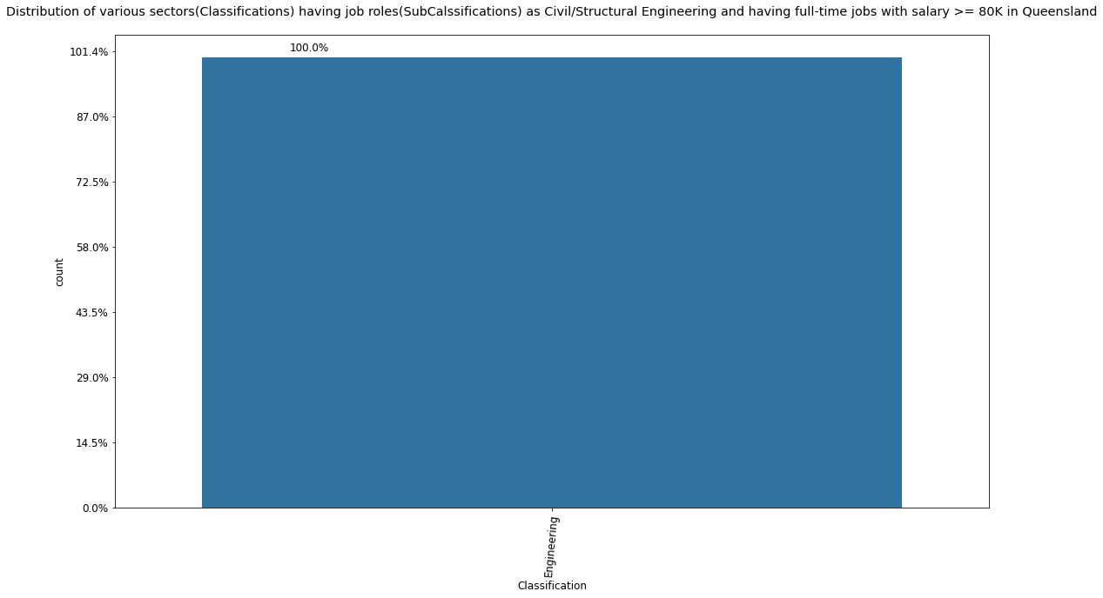

* General Practitioners

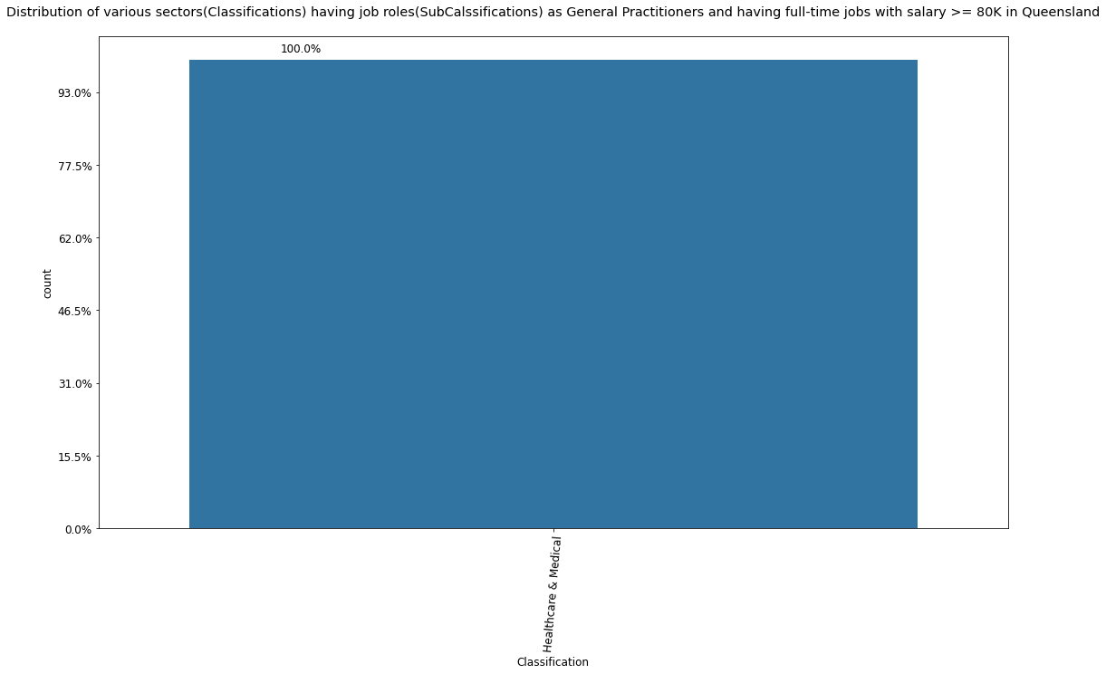

* Developers/Programmers

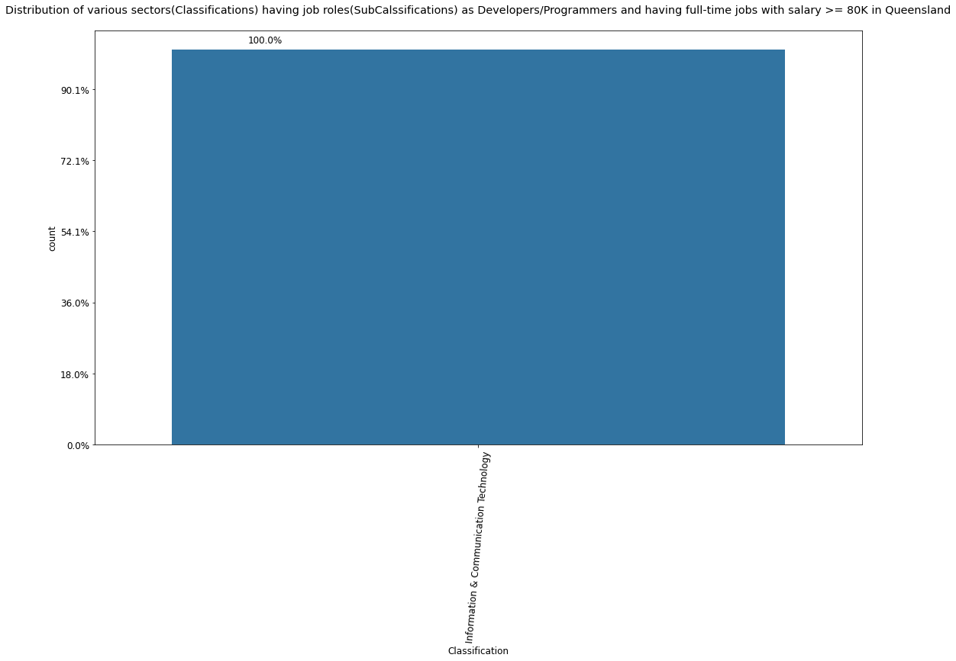

Hence, we suggest the following Majors and their related subjects:

* Management courses:
  + Bachelor of Business Administration- (BBA)
  + Business Management – (BBM)
  + Management Studies- (BMS)
  + Commerce (Management)- B.Com (Management)
  + Computer Aided Management- (B.CAM)
  + Bachelor of Computer Application + Executive Master of
  + Business Administration
  + Bachelors in Business Economics- (BBE)Sc (Management)
  + Bachelor of Hospital Management- BHA
* Management Subjects:
  + Marketing Management
  + Finance
  + Operational Management
  + Human Resource Management
  + Business Law and Policy
  + Cost and Management Accounting
  + Computer Practise
  + Entrepreneurship
* Information Technology Courses:
  + B.E. or B.Tech. in Information Technology – 4 years
  + B.E. or B.Tech. in Information and Communication Technology – 4 years
  + B.E. or B.Tech. in Information Security – 4 years
  + BCA (Bachelor of Computer Application) – 3 years
  + BIT (Bachelor of Information Technology) – 3 years
  + B.Sc. IT – 3 years
  + Integrated (B.E./B.Tech. + M.E./M.Tech.) Computer Engineering – 5 years
  + BBA in IT – 3 years
  + BA (IT) – 3 years
  + B.Com. (IT) – 3 years
* Information Technology Subjects:
  + Data Structures
  + Discrete Structures and Graph Theory
  + Computer Based Numerical and Statistical Techniques
  + Digital Logic and Design
  + Soft Computing
  + Multimedia and Animation
  + Operating Systems
  + Theory of Automaton and Formal Languages
  + Information Theory and Coding
  + Cyber Security
  + Web tech
  + Design and Analysis of Algorithms
  + Database Management Systems
  + Principles of Programming Languages
  + Management of Information Systems
  + Computer Networks
  + Software Engineering
  + Compiler Design
  + Artificial Intelligence
  + Distributed Systems
  + Cryptography and Network Security
* Healthcare & Medical Courses:
  + Doctor (MBBS)
  + Veterinary (B.V.Sc)
  + Homeopathy (BHMS)
  + Ayurveda (BAMS)
  + Optometry (B.Optom.)
  + Public Health Administration
  + Occupational Therapy
  + Physiotherapy
* Healthcare & Medical Subjects:
  + Human Anatomy
  + Human Physiology Including Bio-Physics
  + Biochemistry
  + Introduction to Humanities & Community Medicine
  + Forensic Medicine including Toxicology
  + Dermatology and Sexually Transmitted Diseases
  + Orthopaedics
  + Radiotherapy
  + Ophthalmology
  + Obstetrics and Gynaecology
  + Bachelor of Medicine and Bachelor of Surgery
  + Specialisations
  + General Medicine
  + General Surgery
  + Paediatrics
  + Obstetrics & Gynaecology
  + Dermatology
  + Ophthalmology
  + Orthopaedics
  + E.N.T. (Ear, Nose and Throat)
  + Psychiatry
  + Anaesthesiology

### 

### 

### 

### 

### 

### 

### 

### 

### 

### 

### 

### 

### 

### 

### 

### 

### 

### 

### 

### Scenario 2

To gain a better reputation, Awesome University wants to attract more students by enhancing the employability of the graduates. As a data analyst, you need to give the recommendation for the management board for the changing of the admission numbers in each major. Which majors should be extended, and which majors should be reduced (Assume that we only need to use job market data, regardless of other factors such as social impact, economic impact, etc. )? Justify your recommendation.

**Explanation**

As we know that the Awesome University wants to attract more students by enhancing the employability of the graduates, we thoroughly analysed the Job-Market Dataset to come up with the suggestions of which majors should be extended and which majors should be reduced. All of the insights are discussed below:

1. We started off by looking for industry(Classifications)-wise distribution of jobs in the provided dataset. We found the following insights:

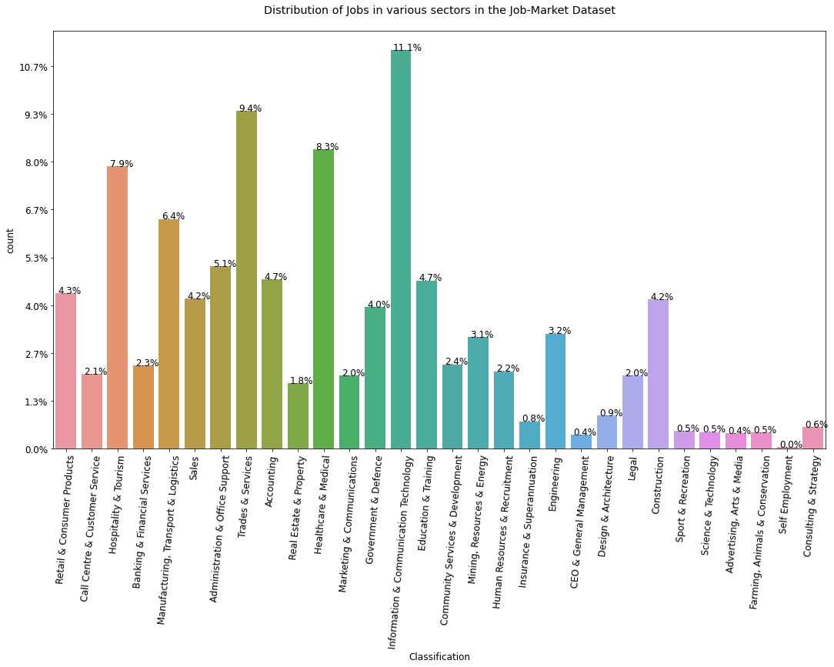

The top 10 industries(with decreasing number of jobs) are:

* Information & Communication Technology
* Trades & Services
* Healthcare & Medical
* Hospitality & Tourism
* Manufacturing, Transport & Logistics
* Administration & Office Support
* Accounting
* Education & Training
* Retail & Consumer Products
* Sales

1.1 The SubClassifications in Top 5 Classifications are mentioned below:

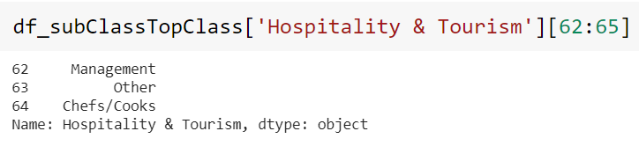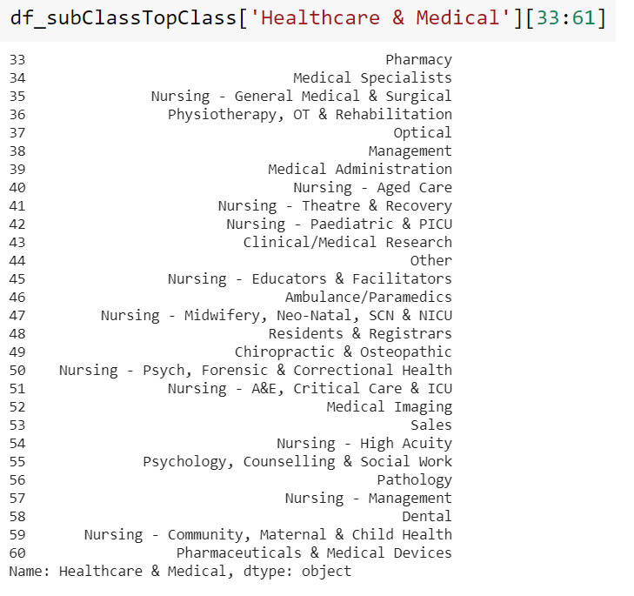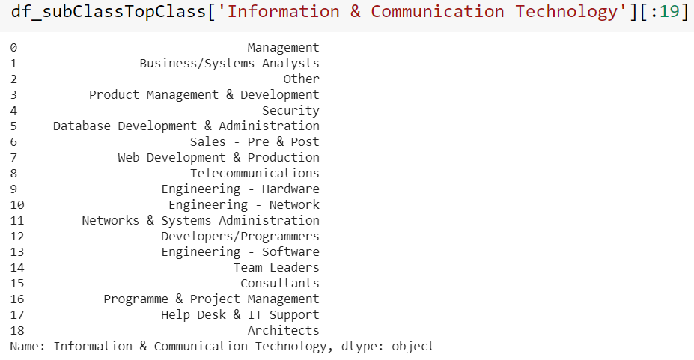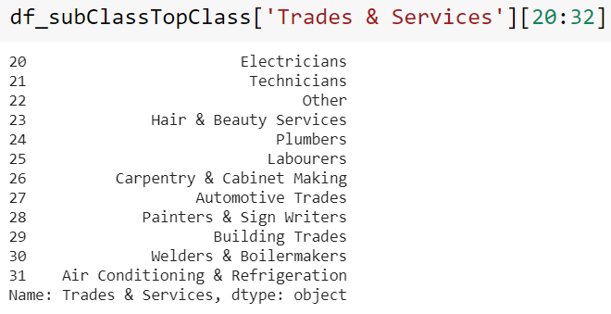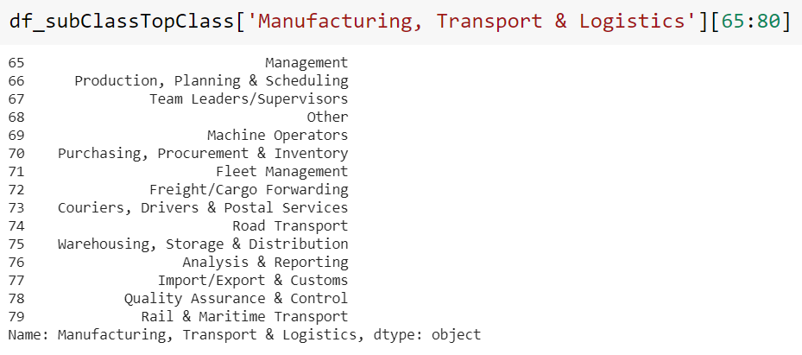

1.2 The SubClassifications in Bottom 5 Classifications are mentioned below:

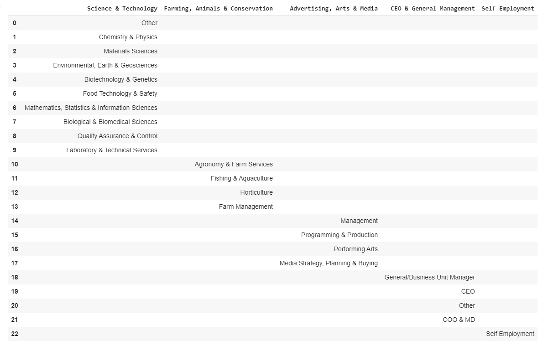

2. Next, we proceeded by finding out the top 15 Job-Roles(SubClassifications) in these industries(Classifications). We found the following insights:

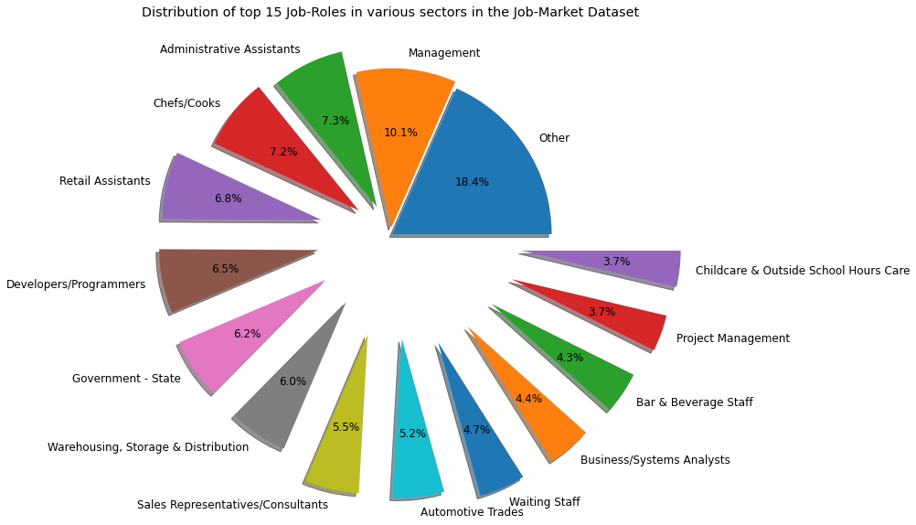

3. Next, we proceeded by finding out the lowest 15 Job-Roles(SubClassifications) in these industries. We found the following insights:

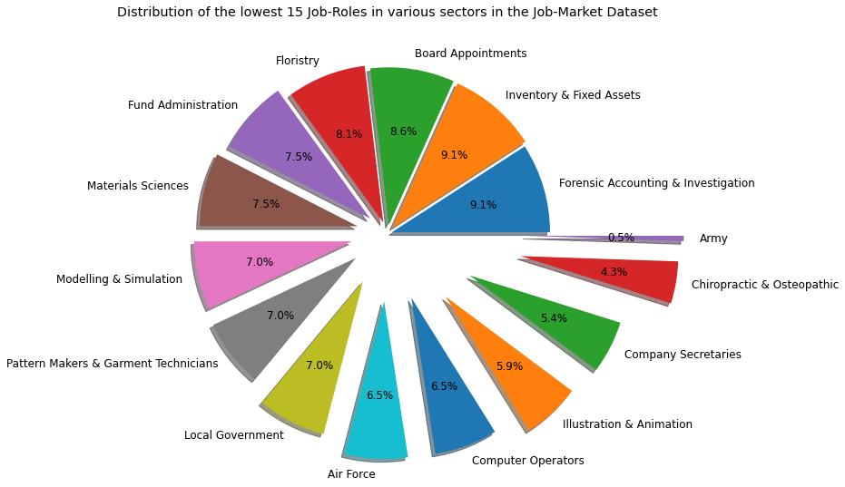

4. Since, the job-role(SubClassifications) mentioned as 'Others' (in pie-plot in point 2) constitutes the most percentage of jobs, we analysed it further to identify which industries these jobs belong to. We found the following insights:

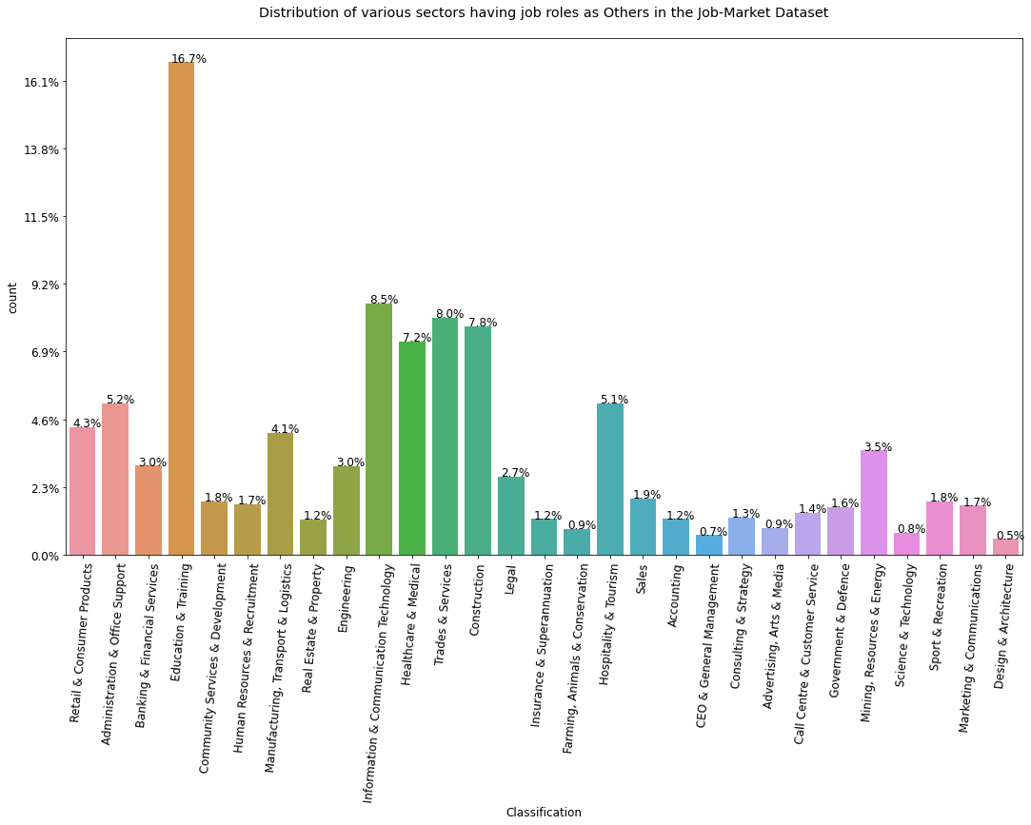

5. The top 10 job roles(SubClassifications) in the above graph are:

* Education & Training
* Information & Communication Technology
* Trades & Services
* Construction
* Healthcare & Medical
* Administration & Office Support
* Hospitality & Tourism
* Retail & Consumer Products
* Manufacturing, Transport & Logistics
* Mining, Resources & Energy

6. The lowest 10 job roles in the above graph(point 4) are:

* Call Centre & Customer Service
* Consulting & Strategy
* Accounting
* Insurance & Superannuation
* Real Estate & Property
* Advertising, Arts & Media
* Farming, Animals & Conservation
* Science & Technology
* CEO & General Management
* Design & Architecture

# Analysis of the Period for which data was collected for Job Market Dataset

1. We started off by looking at the distribution of ads amongst the various days of period for which data was collected for the Job Market Dataset. We found the following:

* First Date of the Job Market Dataset: 2018-10-01 00:00:00+00:00
* Last Date of the Job Market Dataset: 2018-11-13 00:00:00+00:00
* Total no. of days: 43 days 00:00:00

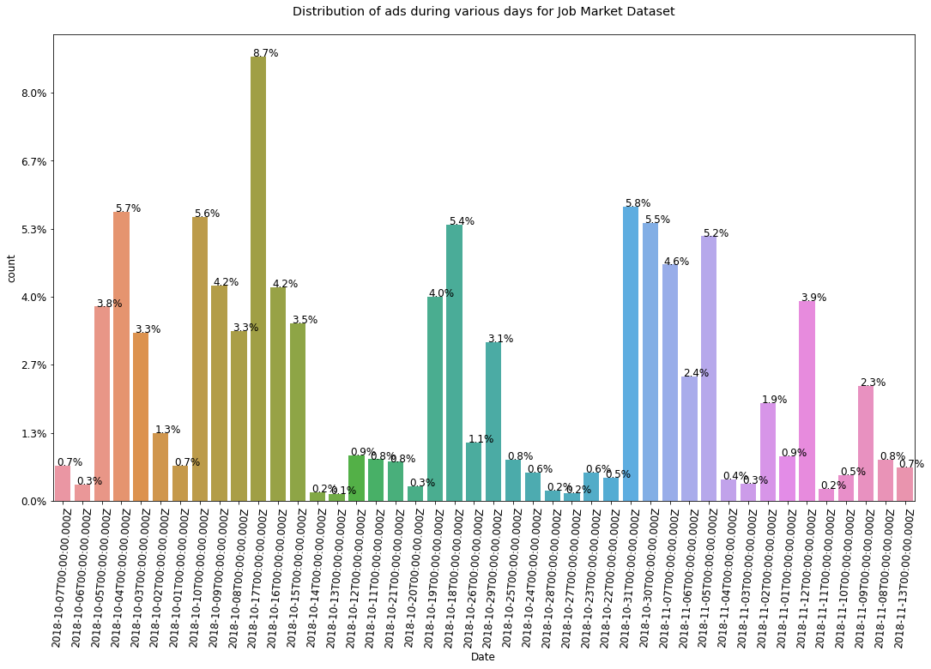

Insights from the above plot:

2018-10-17T00:00:00.000Z 13059

2018-10-31T00:00:00.000Z 8641

2018-10-04T00:00:00.000Z 8506

2018-10-10T00:00:00.000Z 8337

2018-10-30T00:00:00.000Z 8179

2018-10-18T00:00:00.000Z 8121

2018-11-05T00:00:00.000Z 7778

2018-11-07T00:00:00.000Z 6947

2018-10-09T00:00:00.000Z 6329

2018-10-16T00:00:00.000Z 6267

2018-10-19T00:00:00.000Z 5989

2018-11-12T00:00:00.000Z 5865

2018-10-05T00:00:00.000Z 5711

2018-10-15T00:00:00.000Z 5210

2018-10-08T00:00:00.000Z 4995

2018-10-03T00:00:00.000Z 4945

2018-10-29T00:00:00.000Z 4656

2018-11-06T00:00:00.000Z 3654

2018-11-09T00:00:00.000Z 3377

2018-11-02T00:00:00.000Z 2874

2018-10-02T00:00:00.000Z 1980

2018-10-26T00:00:00.000Z 1701

2018-10-12T00:00:00.000Z 1324

2018-11-01T00:00:00.000Z 1316

2018-10-11T00:00:00.000Z 1221

2018-10-25T00:00:00.000Z 1205

2018-11-08T00:00:00.000Z 1199

2018-10-21T00:00:00.000Z 1145

2018-10-07T00:00:00.000Z 1037

2018-10-01T00:00:00.000Z 1023

2018-11-13T00:00:00.000Z 986

2018-10-24T00:00:00.000Z 835

2018-10-23T00:00:00.000Z 827

2018-11-10T00:00:00.000Z 743

2018-10-22T00:00:00.000Z 688

2018-11-04T00:00:00.000Z 636

2018-11-03T00:00:00.000Z 499

2018-10-06T00:00:00.000Z 471

2018-10-20T00:00:00.000Z 422

2018-11-11T00:00:00.000Z 343

2018-10-28T00:00:00.000Z 291

2018-10-14T00:00:00.000Z 239

2018-10-27T00:00:00.000Z 232

2018-10-13T00:00:00.000Z 196

* Most number of ads were on date: 2018-10-17 : 13059
* Least number of ads were on date: 2018-10-13 : 196
* Average number of ads for the period is: 3409

1. Next, we proceeded by finding out the distribution of the ads amongst the Day Of Week. We found the following:

Wednesday 42764

Monday 30215

Tuesday 28222

Thursday 21568

Friday 20976

Sunday 3691

Saturday 2563

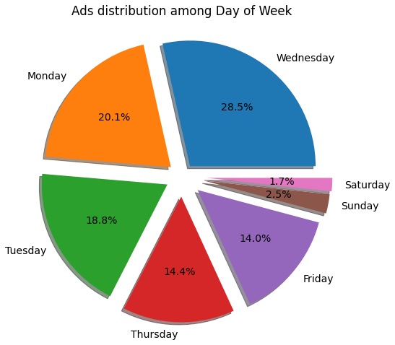

Job Types Forecasting Analysis

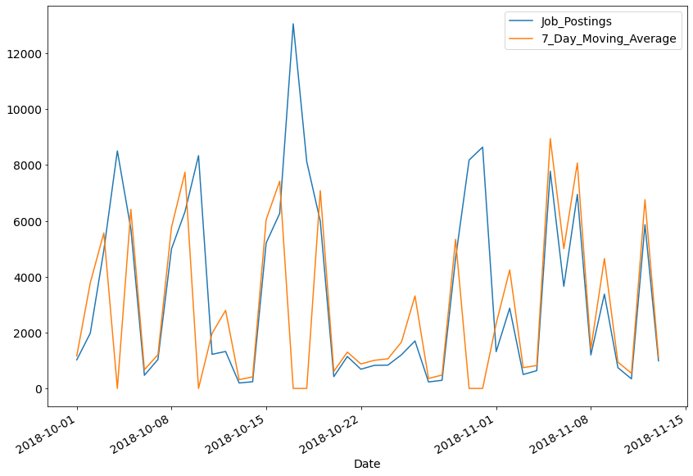

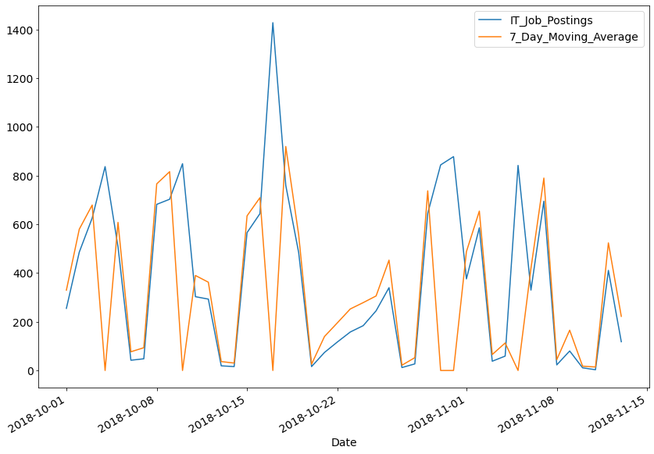

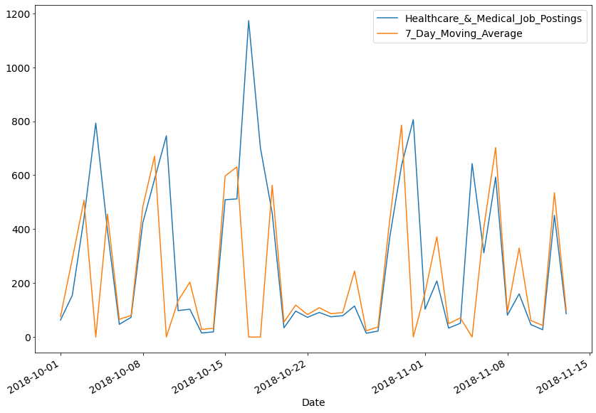

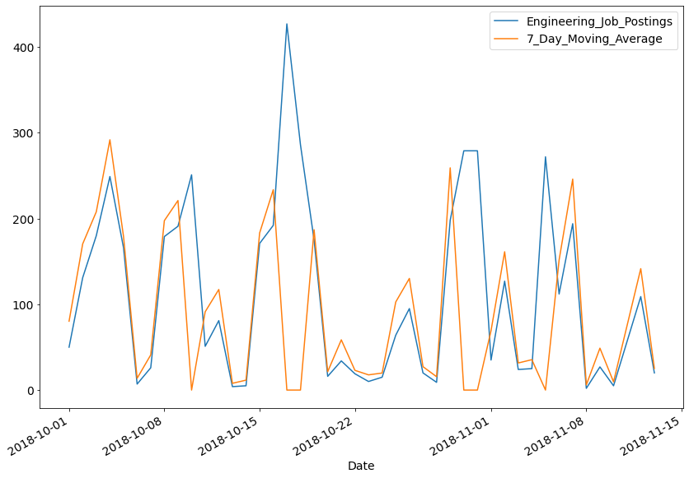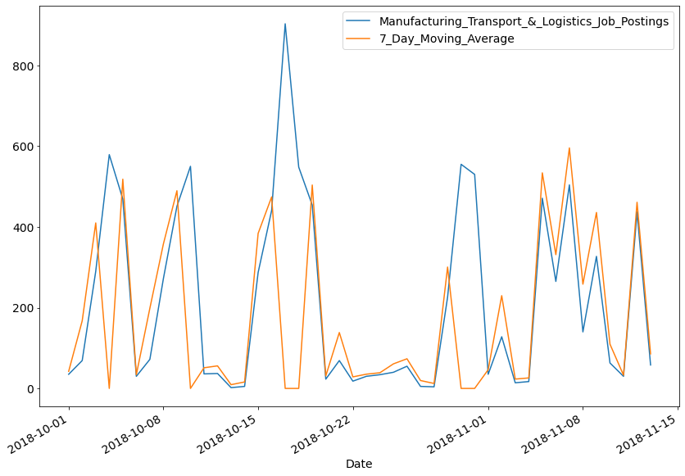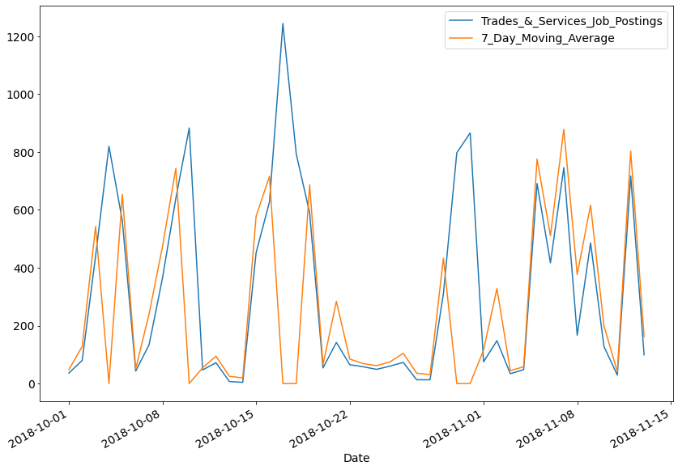

After the thorough analysis of the Job-Market Dataset we come up with the suggestions of which majors should be extended and which majors should be reduced.

* Majors to be extended:
  + Information Technology Majors to be extended:
    - B.E. or B.Tech. in Information Technology – 4 years
    - B.E. or B.Tech. in Information and Communication Technology – 4 years
    - B.E. or B.Tech. in Information Security – 4 years
    - BCA (Bachelor of Computer Application) – 3 years
    - BIT (Bachelor of Information Technology) – 3 years
    - B.Sc. IT – 3 years
    - Integrated (B.E./B.Tech. + M.E./M.Tech.) Computer Engineering – 5 years
    - BBA in IT – 3 years
    - BA (IT) – 3 years
    - B.Com. (IT) – 3 years
  + Management Majors to be extended:
    - Bachelor of Business Administration- (BBA)
    - Business Management – (BBM)
    - Management Studies- (BMS)
    - Commerce (Management)- B.Com (Management)
    - Computer Aided Management- (B.CAM)
    - Bachelor of Computer Application + Executive Master of
    - Business Administration
    - Bachelors in Business Economics- (BBE)Sc (Management)
    - Bachelor of Hospital Management- BHA
  + Healthcare & Medical Majors to be extended:
    - Doctor (MBBS)
    - Veterinary (B.V.Sc)
    - Homeopathy (BHMS)
    - Ayurveda (BAMS)
    - Optometry (B.Optom.)
    - Public Health Administration
    - Occupational Therapy
    - Physiotherapy
* Domains where majors should be reduced:
  + Design & Architecture
  + Consulting & Strategy
  + Sport & Recreation
  + Farming, Animals & Conservation
  + Advertising, Arts & Media
  + Floristry
  + Materials Sciences
  + Fund Administration
  + Pattern Makers & Garment Technicians
  + Modelling & Simulation
  + Computer Operators
  + Illustration & Animation
  + Company Secretaries
  + Chiropractic & Osteopathic

# 

### Reference links:

* <https://www.mindler.com/blog/medical-courses-after-12th/>
* <https://www.skillsacademy.co.za/subjects-required-for-business-management/>
* <https://www.quora.com/What-are-subjects-in-information-technology-1>
* <https://www.apnaahangout.com/information-technology-courses-after-12th/>
* <https://nvshq.org/admission/list-of-management-courses-after-12th/>